Name: Majid Ali
CMS ID: 053-25-0017
Course: Java (Lab: 10)

Task No: 1
class BankAccount{
private String accountNumber;
private String holderName;

public BankAccount(String accountNumber, String holderName){
this.accountNumber = accountNumber;
this.holderName = holderName;
}
public void display(){
System.out.println("Account Number: " + accountNumber + "\nHolder Name: "+ holderName);

}
public double annualInterestRate(){
return 0.5;
}
}

class SavingAccount extends BankAccount{
private double minimumbalance;

public SavingAccount(String accountNumber, String holderName){
super(accountNumber, holderName);
}
public double annualInterestRate(){
return 4.0;
}
public void display(){
super.display();
System.out.println("Account : Saving Account");
}
}
class CurrentAccount extends BankAccount{
public CurrentAccount(String accountNumber, String holderName){
super(accountNumber, holderName);
}
public double annualInterestRate(){
return 0.1;
}
public void display(){
super.display();
System.out.println("Account : Current Account");
}

}
public class l10aq1{
public static void main(String args[]){
BankAccount bank = new BankAccount("826016298126" , "Waroon Kumar");
SavingAccount saving = new SavingAccount("563403258", "Soem Panjwani");
CurrentAccount current = new CurrentAccount("94893030", "Sahil Batra");

bank.display();
System.out.println("Account Interest: " + bank.annualInterestRate() + "%\n");
saving.display();
System.out.println("Account Interest: " + saving.annualInterestRate() + "%\n");
current.display();
System.out.println("Account Interest: " + current.annualInterestRate() + "%");
}
}
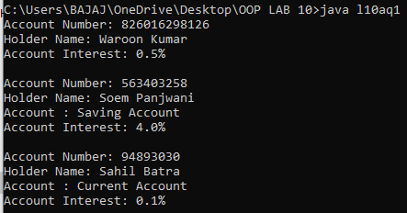

Task No: 2
class Meal{
private String mealName;
private double listPrice;

public Meal(String mealName, double listPrice){
this.mealName = mealName;
this.listPrice = listPrice;
}

public void display (){
System.out.println("Meal Name: " + mealName + "\nList Price: "+ listPrice);
}
public double price(){
return listPrice;
}
}

class StudentsMeal extends Meal{
public StudentsMeal(String mealName, double listPrice){
super(mealName, listPrice);
}
public double price(){
double p = super.price()*0.50;
return p;
}
}
class FacultyMeal extends Meal{
public FacultyMeal(String mealName, double listPrice){
super(mealName, listPrice);
}
public double price(){
double pr = super.price()*0.75;
return pr;

}
}

public class l10q2{
public static void main(String args[]){
Meal meal = new Meal("Biryani", 300);
StudentsMeal smeal = new StudentsMeal("Biryani", 300);
FacultyMeal fmeal = new FacultyMeal("Biryani", 300);

meal.display();
System.out.println("Price of Meal: " + meal.price() + "\n");

smeal.display();
System.out.println("Price of Meal for Students: " + smeal.price() + "\n");
fmeal.display();
System.out.println("Price of Meal for faculty: " + fmeal.price());

}
}
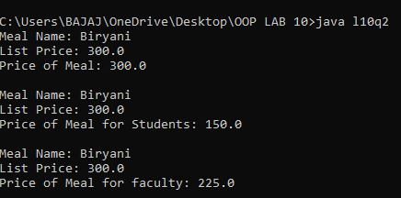
Task NO: 3
class HotelRoom{
private String roomCode;
public HotelRoom(String roomCode){
this.roomCode = roomCode;
}
public void display(){
System.out.println("Room Code: " + roomCode);
}
public double nightlyRate(){
return 3000.0;
}
}
class StandaradRoom extends HotelRoom{
private int bedCount;
public StandaradRoom(String roomCode){
super(roomCode);
}
public double nightlyRate(){
return 5500.0;
}
public void display(){
System.out.println("\nStandarad Room");
super.display();
}
}
class Suite extends HotelRoom{
public Suite (String roomCode){
super(roomCode);
}
public double nightlyRate(){
return 12000.00;
}
public void display(){
System.out.println("\nSuite Room");
super.display();
}
}
public class l10q3{
public static void main(String args[]){
HotelRoom hr = new HotelRoom("101");
StandaradRoom sr = new StandaradRoom("205");
Suite suiteroom = new Suite("509");
hr.display();
System.out.println("Nightly Charges of normal Room: " + hr.nightlyRate() + "\n");
sr.display();
System.out.println("Nightly Charges of Standarad Room: " + sr.nightlyRate() + "\n");
suiteroom.display();
System.out.println("Nightly Charges of Suite: " + suiteroom.nightlyRate() + "\n");
}
}
